Project Title: bite bright

1.1 Topic Selection and Requirements Elicitation

Project Topic: Modern diet management systems often focus heavily on calorie counting, which can lead to food-related anxiety and unsustainable eating habits. This project aims to create a system that tracks food intake, promotes emotional well-being, and encourages healthy eating patterns through personalized, sustainable recommendations.

Functional Requirements:

**1- Food Intake Tracking**

* Track users' daily meals, categorizing them into "healthy" and "unhealthy" based on the 80/20 principle.

**2- Health Monitoring**

* Collect health data from wearables or manual input to monitor overall health metrics**.**

**3- Personalized Diet Recommendations**

* Generate recommendations tailored to the user's lifestyle, nutritional needs, and emotional health**.**

**4- Meal Planning Assistance**

* Create weekly meal plans aligned with dietary goals and the 80/20 principle.

**5- Real-Time Feedback and Alerts**

* Send notifications for deviations from healthy eating patterns or when goals are at risk.

**6- Progress Visualization**

* Provide dashboards with trends in diet quality, adherence, and health improvement over time.

**7- Emotional Health Insights**

* Analyze emotional health patterns related to eating and offer strategies to reduce food-related stress or guilt.

**8- Integration with Health Information Systems (HIS)**

* Incorporate dietary tracking and health monitoring into existing HIS platforms.

**9- Social Engagement**

* Enable community features for sharing tips, recipes, and encouragement.

**10- Behavioral Analysis**

* Track eating patterns to suggest incremental, sustainable improvements in habits.

**Non-**Functional Requirements:

**1. Usability**

• Goal: Enable effective use for healthy lifestyle management.

• Metrics:

1. User satisfaction: ≥ 4.5/5.
2. Learnability: ≤ 3 minutes to create the first weekly plan.
3. Plan generation: ≤ 10 seconds.
4. Error rates: ≤ 5% users face errors.

**2. Performance**

• Handle up to 2,000 concurrent users.

• Response times: ≤ 500ms (normal load), ≤ 2 seconds (stress).

• Transactions: ≥ 1,000 per minute (TPM).

• CPU/memory usage: ≤ 70% (normal), ≤ 90% (stress).

**3. Security**

• Full AES-256 encryption for sensitive data.

• Block 100% of unauthorized access attempts.

• Maintain uptime ≥ 99.9%.

**4. Scalability**

• Efficient horizontal scaling with ≤ 2 additional servers for 10,000 users.

• ≥ 40% performance improvement with 50% more resources.

**5. Maintainability**

• High-priority bugs resolved in ≤ 24 hours.

• Minor updates deployed in ≤ 30 minutes.

• ≥ 85% code test coverage.

**6. Accessibility**

• Ensure 100% screen reader compatibility for critical features.

**7. Reliability**

• MTBF: ≥ 1,000 hours.

• MTTR: ≤ 1 hour to restore functionality.

1.2 Use Case Model

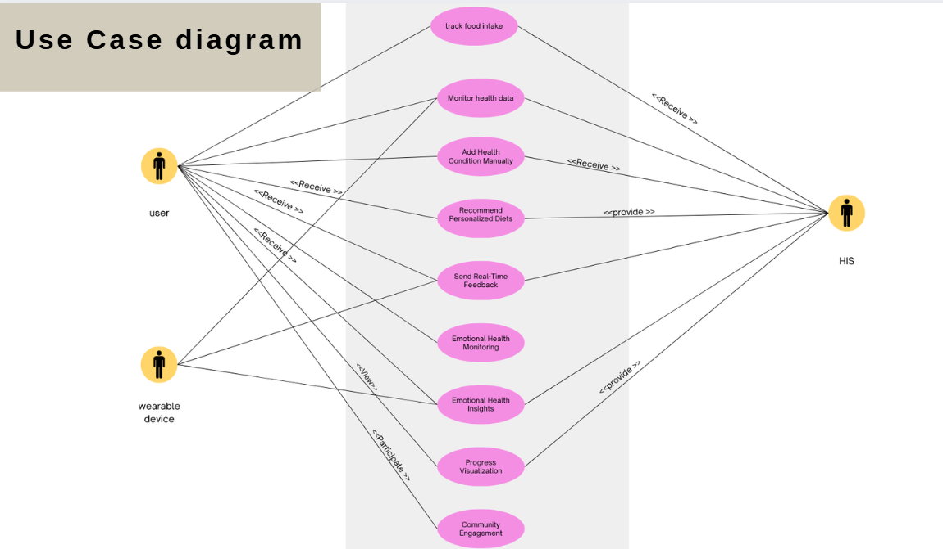

Use cases

**1. Track Food Intake**

**Actor(s):** User  
**Precondition:** The user is logged into the system and has access to the food intake logging interface.  
**Main Flow:**

1. The user inputs meal details, including food items and portion sizes.
2. The system validates the input for completeness and correct formatting.
3. The system logs the entered data.
4. The system confirms the successful entry of the meal.

**Alternative Flow:**

* **Invalid Input Data:**
  + If the input data is missing or incorrectly formatted, the system displays an error message.
  + The user is prompted to re-enter the data.

**Postcondition:** The meal details are successfully stored in the system.

**2. Monitor Health Data**

**Actor(s):** Wearable Device  
**Precondition:** The wearable device is connected and has data available for synchronization.  
**Main Flow:**

1. The wearable device syncs health data (e.g., heart rate, activity levels) with the system.
2. The system processes and stores the synced data.
3. The user's health dashboard is updated with the latest information.

**Alternative Flow:**

* **Sync Failure:**
  + If the wearable device fails to sync, the system notifies the user of the issue.
  + The system retries the synchronization process after a defined interval.

**Postcondition:** The health data is successfully synced and reflected in the user's health dashboard.

**3. Categorize Meals**

**Actor(s):** User  
**Precondition:** The user has logged at least one meal and has access to the meal categorization interface.  
**Main Flow:**

1. The user categorizes meals as "healthy" or "unhealthy."
2. The system validates the categorization using predefined rules.
3. The categorized data is stored for future analysis.

**Alternative Flow:**

* **Uncategorized Meal:**
  + If a meal cannot be categorized automatically, the system suggests likely categories.
  + The user confirms or overrides the suggested categorization.

**Postcondition:** Meal categorizations are successfully saved in the system.

**4. Provide Personalized Diet Recommendations**

**Actor(s):** User  
**Precondition:** The user has logged food intake and health data, and sufficient data is available for analysis.  
**Main Flow:**

1. The system analyzes the user's health data and food intake.
2. The system generates personalized diet recommendations using the 80/20 principle.
3. The system displays the recommendations to the user.

**Alternative Flow:**

* **Insufficient Data:**
  + If insufficient data is available, the system notifies the user and prompts them to provide the missing information (e.g., logging meals or syncing health data).

**Postcondition:** Personalized diet recommendations are successfully delivered to the user.

**5. Send Real-Time Feedback**

**Actor(s):** User  
**Precondition:** The system is actively monitoring the user's adherence to the 80/20 principle.  
**Main Flow:**

1. The system monitors the user's adherence to the 80/20 balance in real-time.
2. If deviations are detected, the system sends alerts or feedback to the user.

**Alternative Flow:**

* **Feedback Delivery Failure:**
  + If feedback cannot be delivered due to connectivity issues, the system queues the notification.
  + The system retries delivering the feedback once connectivity is restored.

**Postcondition:** Feedback is successfully delivered, or it is queued for future delivery.

**6. Monitor Emotional Health**

**Actor(s):** User  
**Precondition:** The user has access to the emotional health logging interface.  
**Main Flow:**

1. The user logs emotional health data, such as mood and stress levels.
2. The system tracks trends and correlates them with the user's eating patterns.
3. Insights are displayed to the user based on the analysis.

**Alternative Flow:**

* **No Emotional Health Data Logged:**
  + If no emotional health data is logged, the system generates and provides generic insights based on general patterns and existing eating data.

**Postcondition:** Insights are successfully displayed to the user.

-------------------------------------------------------------------------------------

1.3 Domain Model

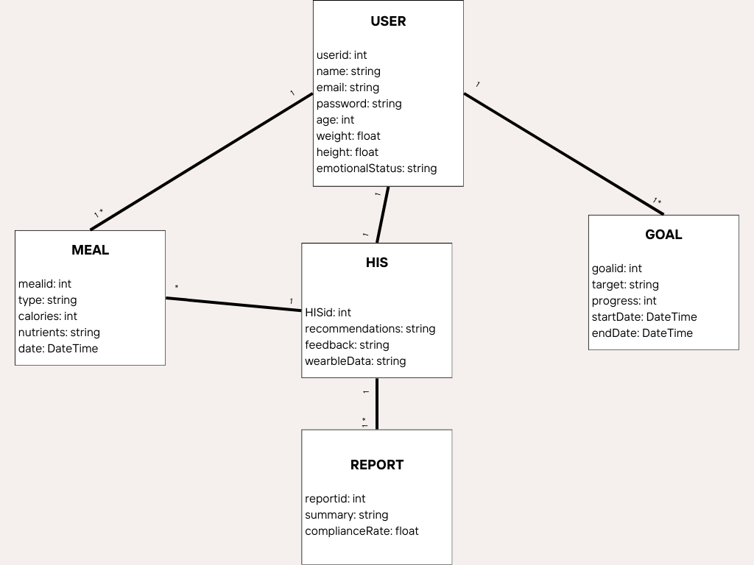

14 System Sequence Diagrams SSD for Personalized Diet Recommendations

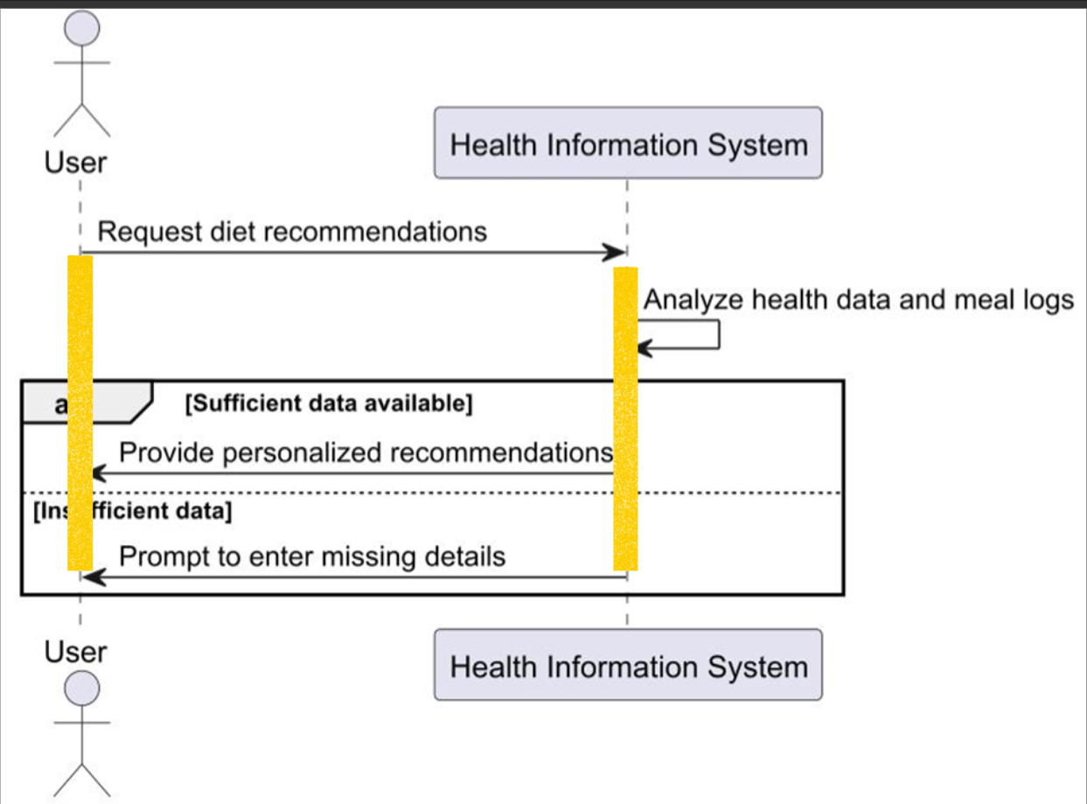

System Sequence Diagram (SSD) for Track Food Intake

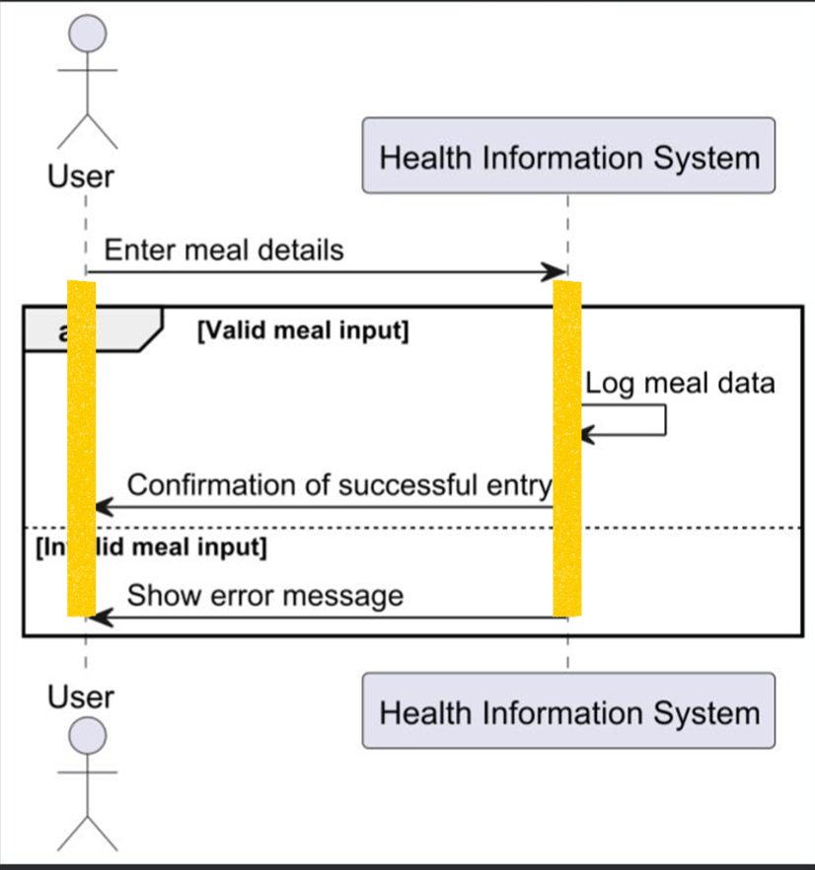

Team Names: 1-habiba Magdy

2-Pakinam Khaled

3-Sama Reda